Enterprise Calendar and Scheduling

Embedded analytics Project

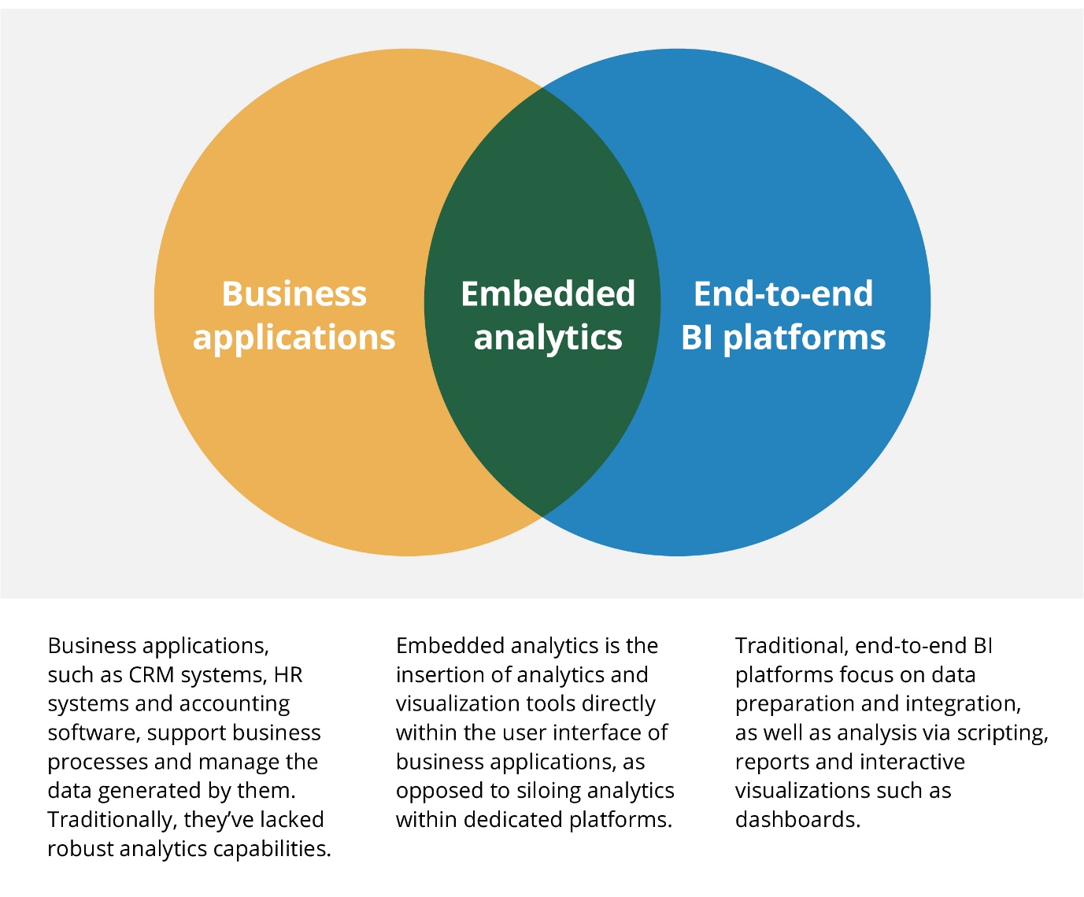

## Data Analytics Project Lifecycle

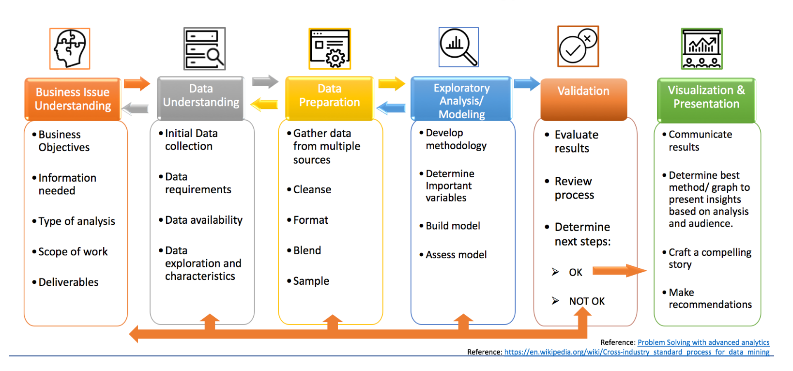

## Business Issue Understanding

Business Objective:

* Identify user needs for embedded analytics.
* Identify the different data levels in each function of ….. to embed analytics:
  + Application Usability:
    - Application access.
  + Application Performance and failures.
  + Application Process:
    - Master Calendar Processes.
    - Schedule Cases Processes.
    - Calendar Search Processes.
* Embed a visualization dashboard.
* Provide best-in-class analytics without sacrificing performance.
* Identify security boundaries.
* Use a third party embedded API framework or customize an application dashboard.
* How are the users impacted by embedded analytics within applications?

Information Needed:

* Process flow diagrams.
* Possible KPI metrics to embed.
* User roles with permission to visualization dashboard(s).
* Data dictionary for each metric to visualized.

Type of Analysis:

* User interaction data collection and possible KPI metrics.
  + User interaction analytics serve to plan for usability testing, A/B testing, field testing, etc.
* Case Processing KPI metrics.
* Correlation, association, trends, outliers, predictions, probabilities can be incorporated into an analytical model and embed it into the application as an algorithm.
  + These additional models, algorithms, might need restructuring of the data.
  + Automate the cleansing of such data.
  + Treat the developing of these algorithms as product development lifecycle process.
  + For effectiveness, biases on the processes results and/or responses should be identified and eliminated if the exist.

Drivers for embedded analytics (scope):

* User’s expectations to include reporting for desktop and mobile applications.
* Information easily accessible across devices and browsers.
* Streamline of UI for wider adoption and product use.
* Spare users from launching separate tools/applications to provide in-context insights without distraction.
* Increase the value of the product.
* Introduce focus groups reporting for user experience analytics.
* Offer more sophisticated analytics.
* Product differentiation for the courts systems.

Deliverables:

* Identify Interfaces, processes and Methods.
* Data dictionaries for each method.
* Identify KPI visualization for each process and access roles.
* Initiate project for embedded KIPs.
* Initiate project for algorithm models.

## Data Understanding

Initial Data collection:

* Static Data
  + Snapshot in time of the data.
  + Provide data ranges.
  + Charting the data in dashboard.
  + Download report.
  + RESTful API if use of an external BI tool.
* Interactive Data experience
  + Filters for different types of reports
    - Identify trends and flag outliers
  + Benefits:
    - Customized user experience in structured reports.
    - Flexibility.

Data Requirements:

* Data streams

Data Availability:

* omitted data
* data that doesn’t logically make sense
* duplicate data
* spelling errors
* missing variables

Data Exploration and Characteristics:

* Data Dictionary creation

## Data Preparation

Data Sources:

Cleanse:

Format:

Blend:

Sample:

## Exploratory Analysis Modeling

Develop Methodology:

Important Variables:

Build Model (tools used):

Assess Model:

## Validation

Evaluate Results:

Review Process:

Next Steps (OK / Not OK):

## Visualization and Presentation

Communicate Results:

Method to present insights:

Craft/Create Compelling Story:

Recommendations:

## Embedded Analytics Possible Visualizations

### Landing Page

|  |  |  |  |
| --- | --- | --- | --- |
| Screen | Analytic Target | Metric | Comments |
| Landing Page | Usability | Entry from rate |  |
|  | Usability | Internal menu selection rate |  |
|  | Process | pending schedules per …… |  |
|  | Process | pending events per …… |  |
|  | Security | User single or multiple access rate |  |
|  | Performance | launching rate |  |
|  | Performance | interface connection rate and failures |  |

Image 1 (Deleted for confidentiality purposes)

Image 2 (Deleted for confidentiality purposes)

### Master Calendar Session List

|  |  |  |  |
| --- | --- | --- | --- |
| Screen | Analytic Target | Metric | Comments |
| Master Calendar |  |  |  |
| Session List | Usability | Search by attributes rates | This will keep track on how my times …… is searched and by what attributes |
|  | Usability | Action click rates | This will keep track on the actions taken by each user. |
|  | Process | Session Scheduled per Year/Month/Day | Report Type by ……. |
|  | Process | Session Time ranges rates | Report Type by ……. |
|  | Process | Session ……., most used | Report Type by ……. |
|  | Process | …….. Sessions rate, most and least | Report Type by …….., can be combined with other variables |
|  | Process | …….. scheduled, most and least, frequency | Report Type by other variables if required. |
|  | Performance | Load list success and failure rate | Or any other action success or failure. |

Image 3 (Deleted for confidentiality purposes)

### Session Schedules

|  |  |  |  |
| --- | --- | --- | --- |
| Screen | Analytic Target | Metric | Comments |
| Session | Usability | Search by attributes rates | This will keep track on how my times a ……. is searched and by what attributes |
|  | Usability | Action click rates | This will keep track on the actions taken by each user. |
|  | Process | Number Schedules by …….. | a history trend, if reschedule too many times can be included |
|  | Process | ……… schedule rate | Which ……… is scheduled the most. |
|  |  |  | can also include a history trend in other or same report |
|  | Process | Schedule ……..Rate | Which ……… is scheduled the most and history trend |
|  | Process | ………… number of occurrence schedules | Which ……….. has the most schedules |
|  | Process | ……………of Occurrences | This could provide data for future analysis such as success rates, etc., if not against privacy for internal and external uses (Ethical considerations) |
|  | Process | ADA Accommodation rates | Can be tied to customers with disabilities and measure if ADA accommodations is being provided. |
|  | Process | Interpreter requested rates | Can measure the rate of different language interpreters needed per county |
|  |  |  | Can measure the number of occurrences per interpreter |
|  |  |  | Can measure if interpreter has been provided or not. |
|  |  |  | Can measure if interpreter is in house or remote |
|  | Process | ………… rates | per …………../ session/year/month/day |
|  | Process | ….. Number of Occurrences | per …………../ session/year/month/day |
|  | Process | … Number yes/no rates | per …………../ session/year/month/day |
|  | Process | … Status Rates | per …………../ session/year/month/day |
|  | Process | .. Indicator | per …………../ session/year/month/day |
|  | Process | …. Indicator | per …………../ session/year/month/day |
|  | Process | ….. Code | per …………../ session/year/month/day |
|  | Process | …../location rates | per …………../ session/year/month/day |

Image 3 (Deleted for confidentiality purposes)

Image 4 (Deleted for confidentiality purposes)

Image 5 (Deleted for confidentiality purposes)